

SIMATS ENGINEERING
Saveetha Institute of Medical and Technical Sciences
Chennai- 602105
Student Name: AYESHA SIDDIQUA.A
R Reg. No:1911260141
Course Code: CSA0801
Slot: C
Course Name: PYTHON PROGRAAMMING
Course Faculty: Dr. SAMSON EBENEZER
Project Title: MOVIE TICKET BOOKING SYSTEM
Module Photographs: (3 photographs –Module Photo, Individual student contribution module work in the project and presentation image)
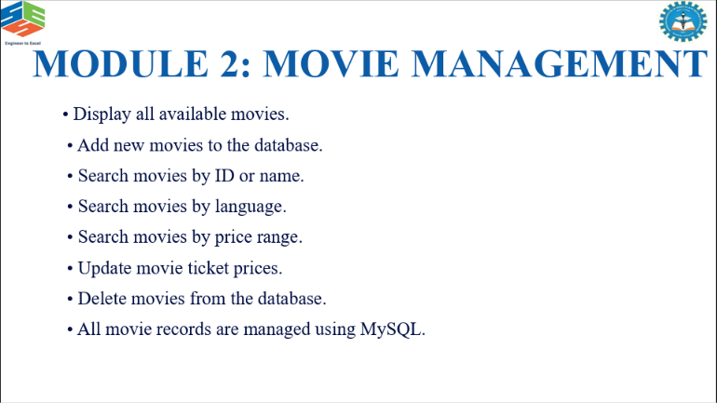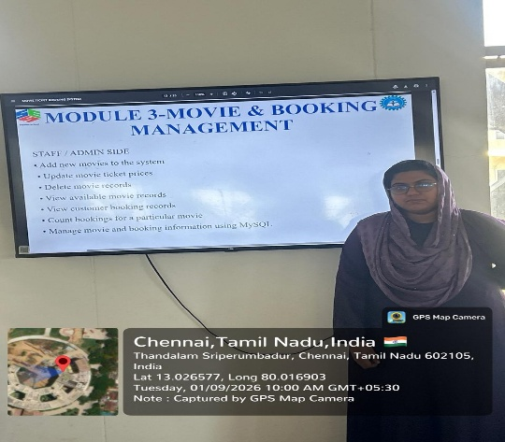

PROJECT DESCRIPTION: MOVIE MANAGEMENT – MODULE 2
Module 2 focuses on managing movie information in the Movie Ticket Booking System. The module allows users to display all available movies and enables new movies to be added to the database. Movies can be searched easily using their ID or name, language, and price range. The system also provides options to update movie ticket prices and delete movie records when they are no longer required. All movie details are stored and managed using a MySQL database, ensuring organized and efficient data management. This module makes it easier to maintain accurate and up-to-date movie information for the ticket booking process.

Student Signature Guide Signature

